Shaun

Lobsinger

19826 W. Lincoln St.

Buckeye, AZ 85326

T: 480-433-6235

E: [shaun.lobsinger@gmail.com](mailto:shaun.lobsinger@gmail.com)

W: <https://shaunlobsinger.com>

# Objective

To innovate new web products with a focus on user experience within a supportive team environment.

# Education

### **MS - Human Factors (Applied Psychology) / 2015**

Arizona State University: Ira A. Fulton Schools of Engineering, Mesa, AZ

### **BS - Psychology / 2011**

Arizona State University: College of Liberal Arts and Sciences, Tempe, AZ

# Skills Summary

**Coding**  
HTML, CSS, SASS, PHP, Node, MySQL, JavaScript, jQuery, Bootstrap 4, React, Redux.

**Technology**   
Git, Webpack, VS Code, Linux

# 

# Experience

### **GoDaddy**

### Software Developer 3 / 1/2017 – Present

At GoDaddy my focus remains on providing top tier experiences to our small business partners. As a senior developer, I help develop a streamlined solution for customers managing their email purchases. Users are able to easily create email accounts, access commonly used functions such as aliases and account management right from a GoDaddy branded experience.  
  
One of my biggest accomplishments has been creating an API endpoint for other GoDaddy applications to access and provision email accounts from other applications. This allows customers to stay in their current flow without disruption but still provision an email account. I was also able to provide consuming applications with a simple React drop in component to simply the integration process.

### **Arizona Federal Credit Union**

### Senior Web Application Developer / 6/2013 – 12/2017

My role at the credit union focused on full stack development, Linux server management, and user experience design. Acting as the sole web developer for the organization, I was responsible for collecting project requirements, creating work flows, developing prototypes, coding and presenting solutions to my stakeholders.

I took the initiative to introduce GIT to the organization as well as implement BitBucket Server and Bamboo Server to provide a complete CI/CD pipeline. I have worked on several business critical applications including two major redesigns of arizonafederal.org, an online membership application, and an online quiz game to coincide with a promotional internet reality show.

# 

# Projects

### **Productivity Email Management Panel (2017)** [**https://productivity.godaddy.com**](https://productivity.godaddy.com)

### Panel is an email management application with the intent to remove the complexity of managing email from Microsoft’s O365 interface and provide users quick access to commonly used features such as email provisioning, password resets, and other features.

***Arizona Federal Redesign (2016)***

[***https://www.arizonafederal.org***](https://www.arizonafederal.org)

A complete overhaul of the Arizona Federal website to modernize the design and functionality. The site includes a responsive design, additional interactive elements implemented in vue.js, and has a striking visual appeal compared to the previous design.   
  
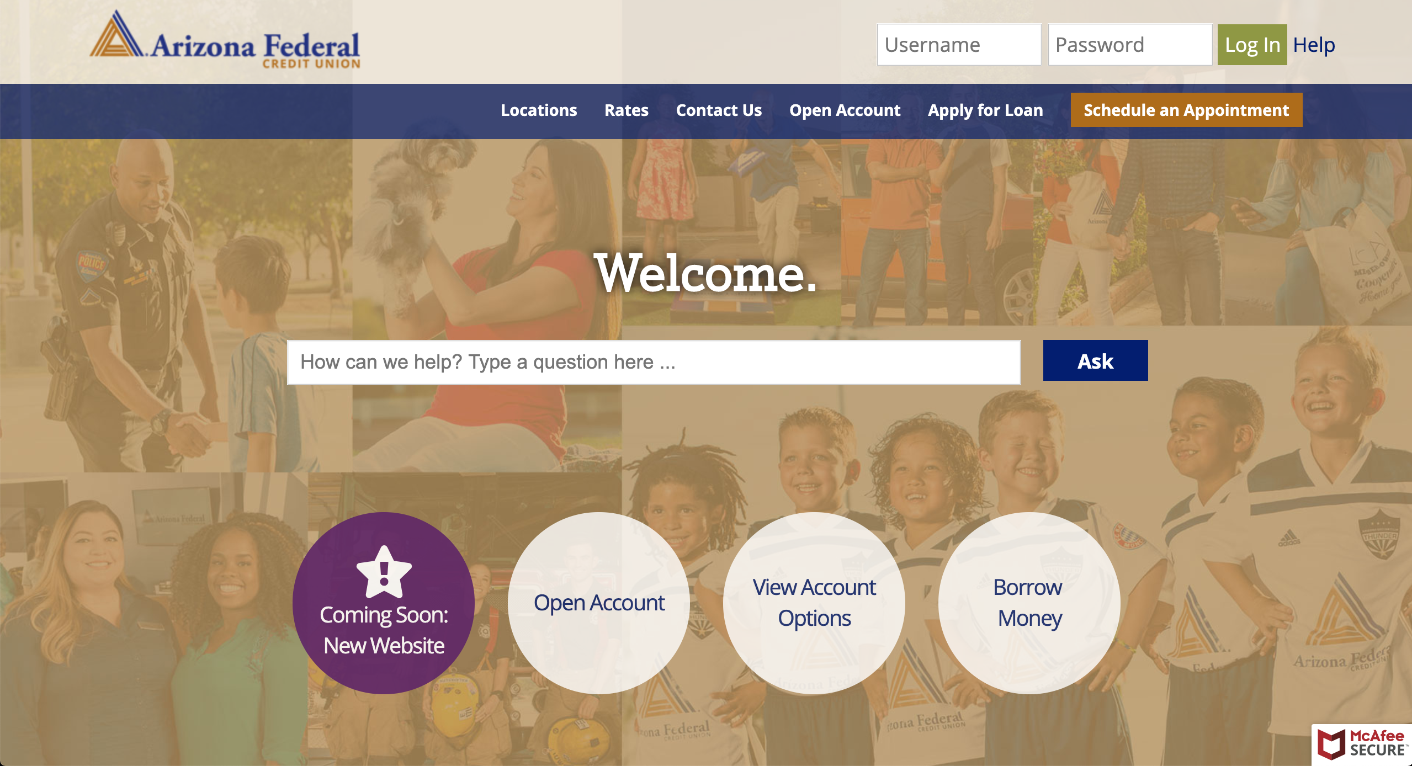

***Arizona Federal Online Membership Application (2015)***

[***https://join.arizonafederal.org***](https://join.arizonafederal.org)

Prior to releasing the membership application, a new member would have to visit a branch to join the credit union. To streamline this process, a multi-step online membership application was implemented to allow users to join the credit union. A backend application was also developed to allow employee to review apps, add notes, and approve memberships.  


***My Comeback (2015)***

[***https://mycomeback.arizonafederal.org***](https://mycomeback.arizonafederal.org)

My Comeback was part of a marketing web campaign used to show potential members the benefits of membership with the credit union. A Laravel 5 companion site was developed to accompany the show with additional content. Viewers were able to log in weekly to complete quizes and questionnaires in order to earn points, which could be turned into contest entries.   
  


# References

### **Jonathan Jolly**

### Human System Analyst – General Dynamics P: 602-909-2869

### **Jesus Islas**

### Digital Banking Manager – Arizona Federal Credit Union P: 623-418-1864

### **Prof. Russell Branaghan**

### Associate Professor – Arizona State University P: 480-276-0731

### **Kenneth Kephart**

### Developer – Jack Henry P: 602-402-7867

Additional references available upon request.